Used Car Price Analytics and Price Prediction
AICTE | IBM SkillsBuild Data Analytics with AI Internship 2026

Conducted by BharatCares in association with AICTE
Student: Hitharth Dasari
Project notebook: HitharthDasari_UsedCarPriceAnalytics.ipynb
Abstract
This project presents an end-to-end Data Analytics and Artificial Intelligence solution for estimating used-car prices. A web-scraped dataset containing 2,840 listings was cleaned, reduced to 2,312 unique records after duplicate removal, explored through statistical and visual analysis, and used to train four regression models. The final executed notebook selects Linear Regression because it achieved the highest held-out Test R² of 0.2935. The project also includes a Python prediction function, a FastAPI REST endpoint and a Streamlit frontend. All Python source code is contained in a single Jupyter notebook; the API and frontend files are generated from notebook cells for runtime use.

1. Introduction
Used-car prices vary with brand, model year, mileage, accident history, ownership history and exterior colour. The project uses these available characteristics to analyse market patterns and build a reproducible price-estimation workflow.

2. Problem Statement
Given vehicle characteristics such as brand, model year, mileage, exterior colour, accident history and number of previous owners, build a data-driven system that estimates the selling price of a used car.

3. Objectives
- Analyse real web-scraped used-car listing data.
- Clean and preprocess the raw dataset.
- Perform exploratory data analysis and generate presentation-quality visualisations.
- Engineer useful vehicle and usage features.
- Train and compare multiple regression models.
- Evaluate models using MAE, MSE, RMSE and R².
- Select and interpret the best-performing model on the held-out test set.
- Build a prediction function, FastAPI backend and Streamlit frontend.
- Keep the complete Python source code in one notebook.

4. Dataset Description
Property | Value
Filename | car_web_scraped_dataset.csv
Source | Kaggle — Car Web Scraped Dataset
Raw rows | 2,840
Duplicate rows removed | 528
Final rows | 2,312
Raw columns | name, year, miles, color, condition, price
Target | price_usd
Final target range | $4,395 – $252,900
Unique brands | 42
Missing values after cleaning | 0
The notebook retains the full price target. Price outliers are identified for EDA only; they are not clipped or removed.

5. Technologies Used
Library | Version | Purpose
pandas | 3.0.0 | Data loading and manipulation
numpy | 2.4.1 | Numerical operations
matplotlib | 3.10.8 | Visualisation
seaborn | 0.13.2 | Statistical visualisation
scikit-learn | 1.9.1 | Preprocessing, models and evaluation
joblib | 1.6.0 | Model persistence
streamlit | 1.64.0 | Interactive frontend
fastapi | 0.141.1 | REST API backend
uvicorn | 0.53.0 | ASGI server
ipywidgets | 8.1.9 | Jupyter widgets

6. System Architecture
Data Layer → Cleaning → EDA → Feature Engineering → Leakage-safe Preprocessing → Train/Test Split → Regression Model Comparison → Model Saving → FastAPI → Streamlit → Prediction Result
All Python source code is maintained in the notebook. Sections of the notebook use %%writefile to generate backend_api.py and streamlit_app.py when the notebook is executed.

7. Methodology
- Load the raw CSV with pandas.
- Remove 528 exact duplicate records.
- Convert price and mileage fields to numeric values.
- Extract exterior colour, accident count, owner count and brand.
- Create vehicle_age, miles_per_year and has_accident features.
- Use a ColumnTransformer with numerical imputation + StandardScaler and categorical imputation + OneHotEncoder.
- Split data 80/20 using random_state=42.
- Train Linear Regression, Decision Tree, Random Forest and Gradient Boosting.
- Evaluate every model on the held-out test set.
- Save the selected pipeline with joblib.

8. Data Cleaning and Feature Engineering
- Price: '$15,988' → 15988.
- Mileage: '41,406 miles' → 41406.
- Colour: 'Gray exterior, Black interior' → exterior_color = Gray.
- Condition: parsed into accidents and owners.
- Brand: extracted from the vehicle name, including multi-word brands such as Mercedes-Benz and Land Rover.
- Duplicates: 528 exact duplicates removed.
- vehicle_age = 2024 − model year.
- miles_per_year provides a usage-intensity proxy while avoiding division by zero for age 0.
- has_accident is 1 when accident count is greater than zero.

9. Exploratory Data Analysis
The following figures are the actual visual outputs embedded in the executed notebook. They are included here rather than recreated from unrelated data.
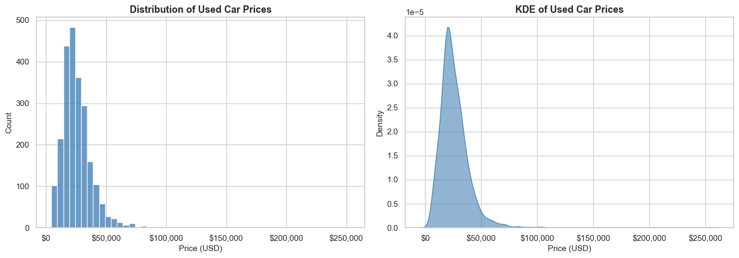
Figure 1. Distribution and KDE of used-car prices.
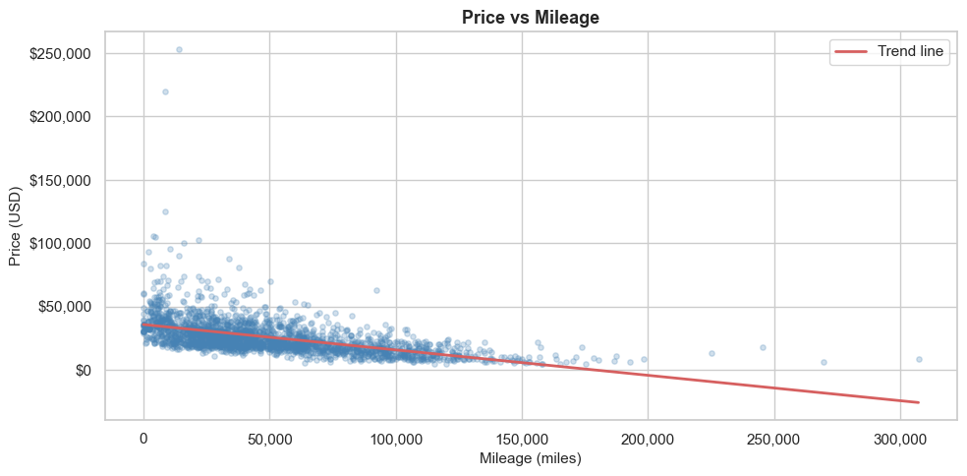
Figure 2. Price versus mileage.

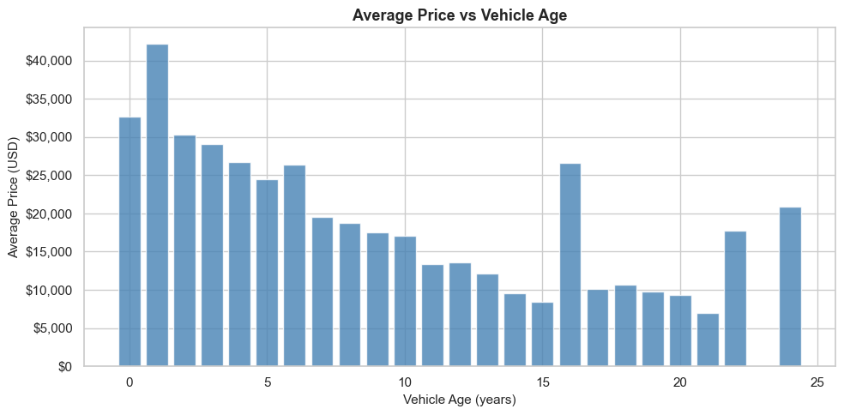
Figure 3. Average price versus vehicle age.
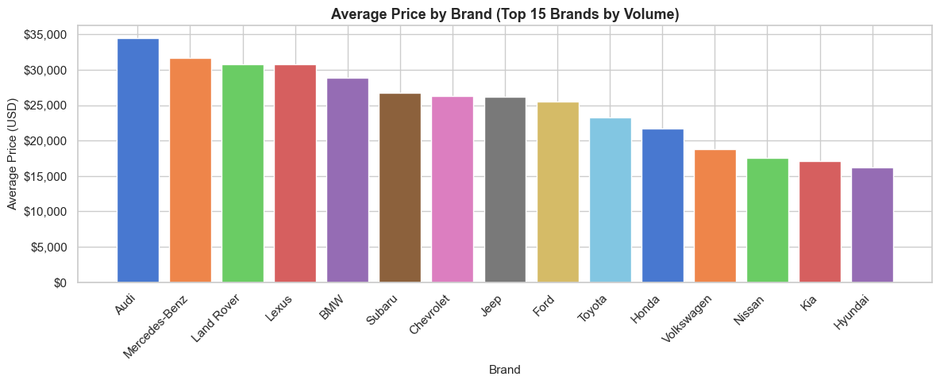
Figure 4. Average price by brand.

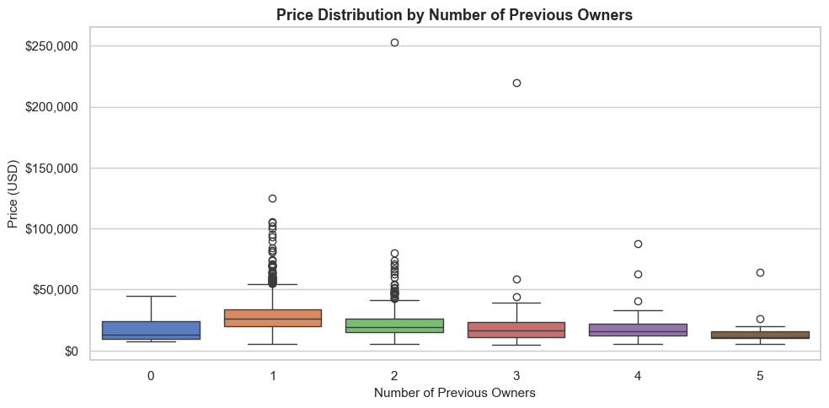
Figure 5. Price distribution by number of previous owners.
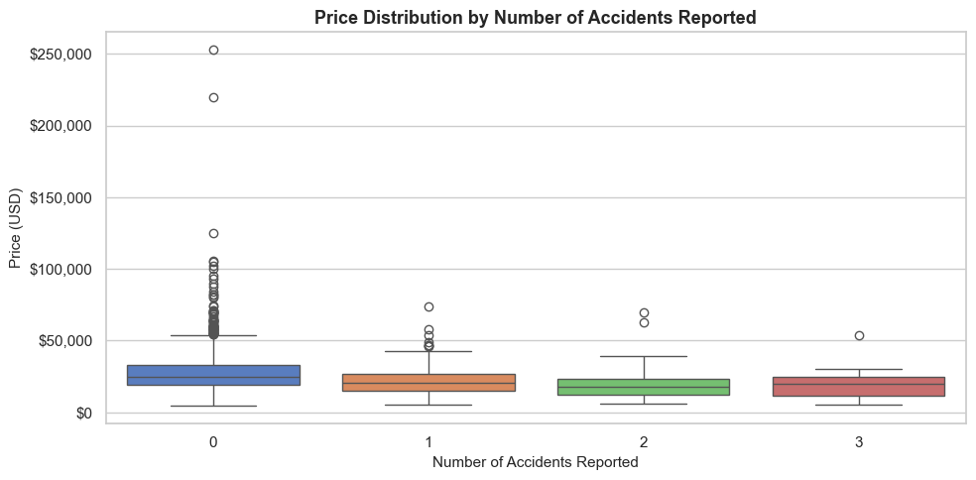
Figure 6. Price distribution by reported accidents.

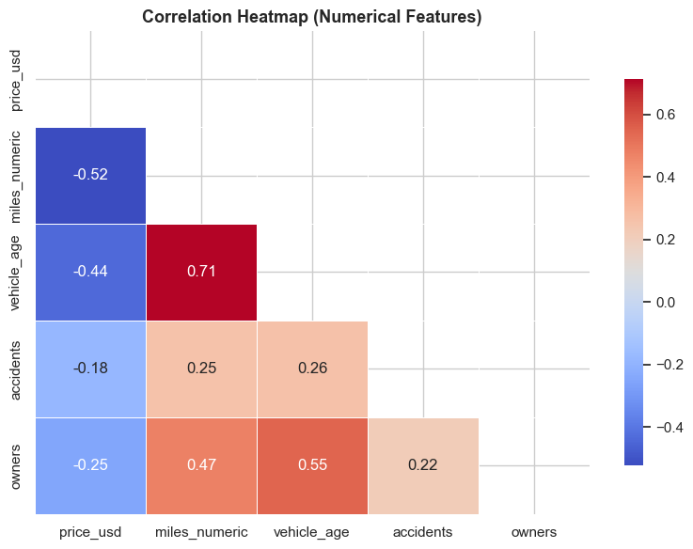
Figure 7. Correlation heatmap of numerical features.
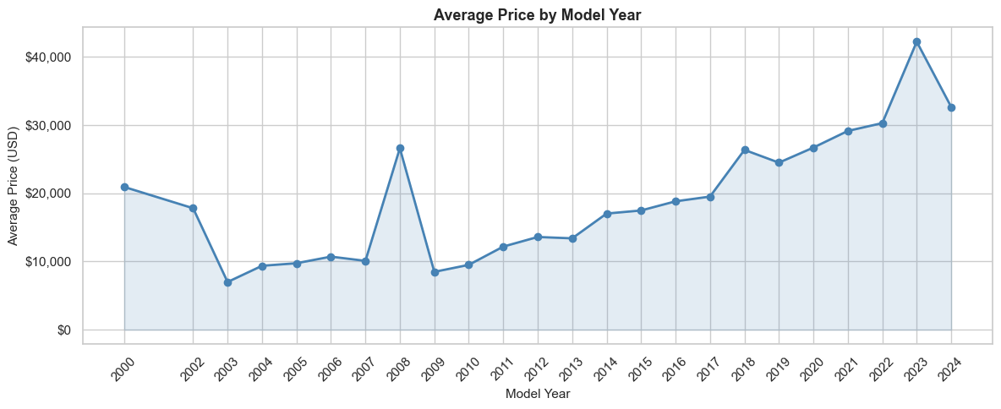
Figure 8. Average price by model year.

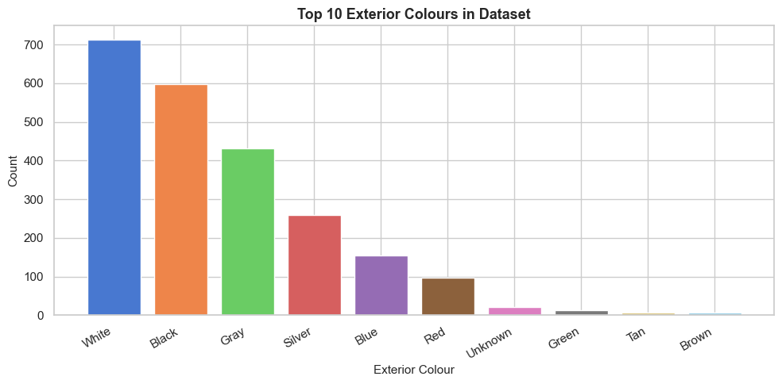
Figure 9. Top exterior colours.
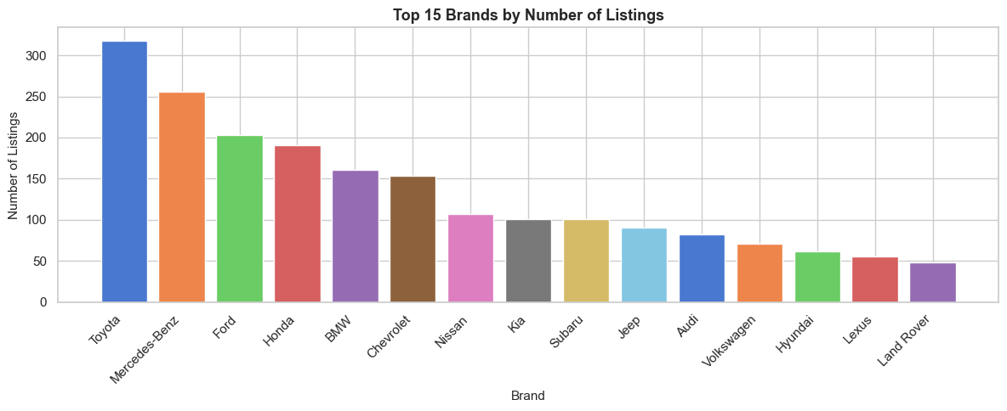
Figure 10. Brand volume / number of listings.

10. EDA Findings
- Mileage has a negative association with price (r = -0.5239).
- Vehicle age has a negative association with price (r = -0.4413).
- Accident count has a negative association with price (r = -0.1816).
- Owner count has a negative association with price (r = -0.2527).
- Premium-brand listings have an observed mean price of about $30,952 versus $23,795 for the standard-brand group; this is an observed difference, not a causal claim.
- Accident-free listings have an observed mean price of about $27,208 versus about $21,000 for listings with at least one reported accident.

11. Machine Learning Models
Four regression models were trained using the same preprocessing pipeline:
- Linear Regression — baseline linear model.
- Decision Tree Regressor — max_depth=10.
- Random Forest Regressor — 200 estimators.
- Gradient Boosting Regressor — 200 estimators, learning_rate=0.1.
The dataset contains 1,849 training rows and 463 test rows. The target is never used as an input feature.

12. Model Evaluation and Comparison
Model | Test MAE ($) | Test RMSE ($) | Test R²
Linear Regression | 6,636.43 | 13,459.74 | 0.2935
Random Forest | 5,906.28 | 13,572.18 | 0.2817
Gradient Boosting | 6,030.15 | 13,635.46 | 0.2750
Decision Tree | 6,992.12 | 14,932.38 | 0.1305
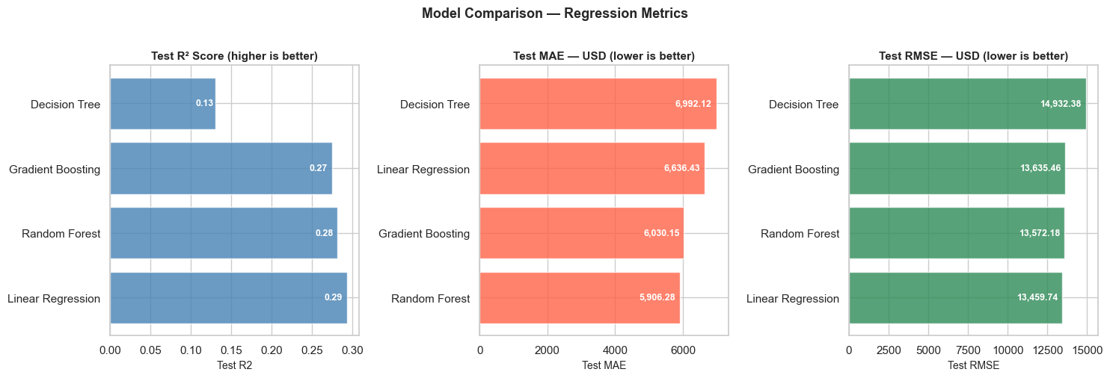
Figure 11. Actual model-comparison visualisation from the notebook.

13. Final Model
Linear Regression is selected because it has the highest Test R² on the held-out test set.
Metric | Final value
Test R² | 0.2935
Train R² | 0.5936
Test MAE | $6,636.43
Test RMSE | $13,459.74
Test MSE | 181,164,582.24
The Train R² versus Test R² gap indicates some overfitting/generalisation gap. This is reported as a limitation of the current feature set and model configuration rather than as a claim that the model is production-ready.

14. Model Interpretation
The final model is Linear Regression, so the notebook does not generate a tree-model feature_importances_ plot. Instead, interpretation is supported by the EDA correlation analysis, observed group differences and the actual-vs-predicted diagnostic.
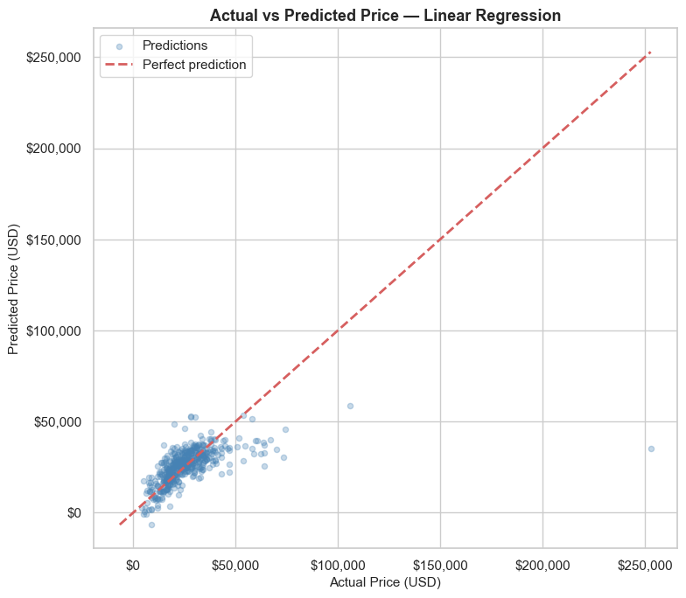
Figure 12. Actual versus predicted prices for the final Linear Regression model.

15. Prediction System
The notebook defines a Python function predict_price(brand, year, miles, exterior_color, accidents, owners). A sample prediction in the executed notebook for a Toyota, 2020, 35,000 miles, Black, 0 accidents and 1 owner was $26,477.52.

FastAPI backend
- Notebook Section 20 writes backend_api.py.
- GET / provides API status/model information.
- GET /health provides a health check.
- POST /predict accepts vehicle attributes and returns predicted_price_usd.
- Interactive API documentation is available at http://localhost:8000/docs when the backend is running.

Streamlit frontend
- Notebook Section 21 writes streamlit_app.py.
- Dashboard page displays dataset statistics and analytics.
- Price Prediction page provides the vehicle input form and prediction result.
- Launch command: streamlit run streamlit_app.py.
- Default address: http://localhost:8501.

16. Frontend → Backend → Model Workflow
User → Streamlit Price Prediction Form → HTTP POST /predict → FastAPI Backend → Saved preprocessing/model pipeline → Linear Regression → JSON prediction → Streamlit displays the result
UI screenshots were not present in the uploaded project artifacts, so this report does not fabricate screenshots. The application pages and launch steps above are documented from the notebook's actual frontend source. Once the dataset and runtime environment are available, screenshots can be captured directly from the running Streamlit app.

17. Limitations
- The dataset does not include fuel type, transmission, engine size or trim level.
- The listings represent a particular scraping period and may not represent current market conditions.
- Some brands and vehicle categories have relatively few examples.
- The current Test R² of 0.2935 leaves substantial unexplained variation.
- The system provides an estimate based on available features and is not a guaranteed market value.

18. Future Scope
- Add fuel type, transmission, engine size, trim and regional information.
- Collect larger and more current market datasets.
- Use cross-validation and hyperparameter tuning.
- Evaluate XGBoost, LightGBM or CatBoost.
- Add SHAP-based explainability.
- Deploy FastAPI and Streamlit to a cloud platform.
- Add periodic retraining using fresh listings.

19. Conclusion
The project demonstrates a complete Data Analytics + AI workflow from raw web-scraped data to an interactive prediction system. After removing duplicate records and avoiding target outlier clipping, the final leakage-safe comparison selected Linear Regression with Test R² = 0.2935 and Test MAE = $6,636.43. The result establishes a working baseline while also showing the need for richer vehicle features and model tuning to improve generalisation.

20. References
- Kaggle — Car Web Scraped Dataset: https://www.kaggle.com/datasets
- scikit-learn documentation: https://scikit-learn.org
- pandas documentation: https://pandas.pydata.org
- Streamlit documentation: https://docs.streamlit.io
- FastAPI documentation: https://fastapi.tiangolo.com
- IBM SkillsBuild: https://skillsbuild.org

